Step 4: System Architecture and Design (SysML Diagrams for Elevator Simulator)

Use Case Diagram – Actors and Interactions
The first step in SysML v1 architecture modeling is to capture high-level functional interactions with a Use Case diagram[1]. In our Simple Elevator Simulator (Example 1), the primary actors are:
- Passenger – a person who uses the elevator (in the simulation, instances of the Person class).
- Simulation Operator – an external entity controlling the simulation (e.g. starting/stopping the simulation run).
Key use cases define what the system does for these actors. For example, a passenger will Call Elevator (request an elevator ride) and then Select Floor (choose a destination floor once inside). The simulation operator can Start/Stop Simulation or Configure Simulation, managing the scenario setup. The use-case diagram represents these interactions graphically: the actors are connected to the use cases that they participate in[2].
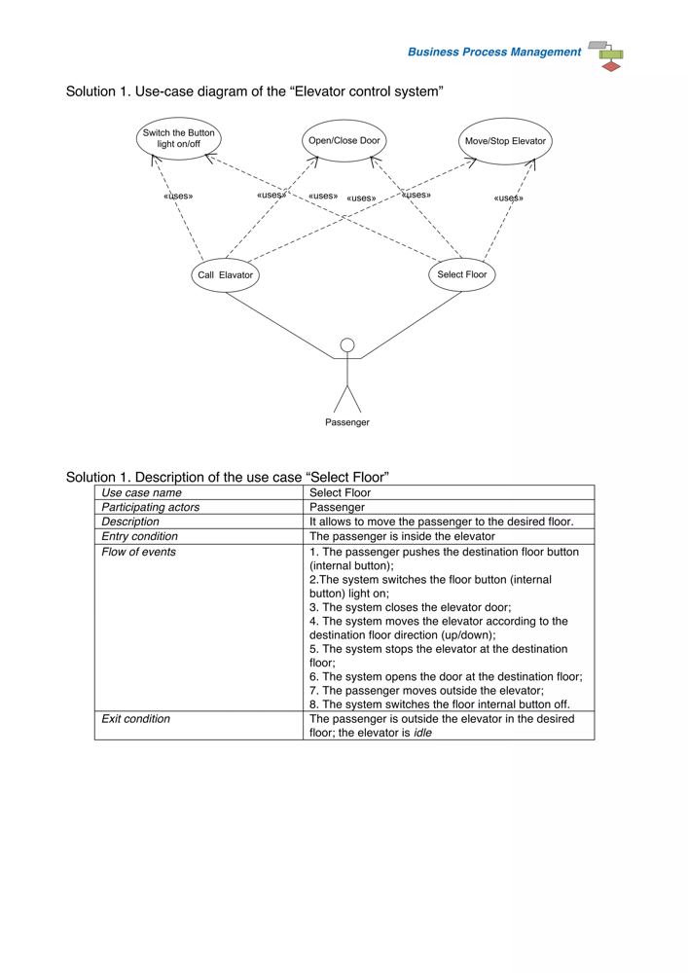
Example SysML use-case diagram for an elevator control system. The Passenger actor interacts with use cases like Call Elevator and Select Floor, which in turn make use of sub-functions such as Open/Close Door and Move/Stop Elevator (denoted by «uses» relationships). In our simulator, the Passenger actor would similarly call the elevator and select a floor. The Simulation Operator (not shown above) would have separate use cases (e.g. Start Simulation) to control the simulation.[3]
Note: The use case Select Floor typically starts after the passenger has entered the elevator (entry condition) and results in the passenger reaching the desired floor (exit condition)[4][5]. By defining use cases, we clarify system boundaries and how external entities (people) interact with the elevator system.

Block Definition Diagram – Structural Decomposition (Classes as Blocks)
With the use cases in mind, the next step is to identify the system’s structural elements. In SysML, Block Definition Diagrams (BDD) show the system’s components (blocks) and their relationships[6][7]. Here, we use the C# classes from the simulator as our SysML blocks:
- Building – the top-level system block representing the entire building or environment. It contains the overall configuration (e.g. number of floors, possibly number of elevators[8]) and aggregates the major components (controllers and elevator). The Building serves as the context in the Internal Block Diagram (next step).
- ElevatorController – the control subsystem for the elevator. This block (analogous to a “Central Control System”[3]) is responsible for coordinating elevator movements and handling requests. It receives calls from passengers and sends commands to the Elevator. In the class design, this would correspond to logic that decides when to move the elevator and to which floor.
- PassengerController – the passenger manager in the simulation. This block generates or manages Person instances (passengers) and their requests. For example, it might spawn passengers at random intervals or handle input events (like a passenger pressing a call button). It acts as an interface between the Person (passenger) and the ElevatorController – in a real system, this could represent the logic that monitors hall buttons or schedules passenger arrivals.
- Elevator – the physical elevator mechanism. The Elevator block encapsulates state like current floor, direction (up/down), and door status. It carries passengers and moves between floors. According to our design, the Elevator keeps track of its position, movement direction, operational state, and the passengers on board[9]. It provides operations like Move() and Stop(), and has attributes such as CurrentFloor and Idle status (as seen in a typical elevator class design[10]).
- Person – represents an individual passenger in the system (could be called Passenger in the model). Each Person has at least a destination floor or desired direction of travel[11]. In the simulation, Person objects would be created by the PassengerController and interact by making elevator requests and boarding or leaving the Elevator. (We distinguish the Person block from the PassengerController – the former is an entity with its own state like Waiting or InElevator, while the latter orchestrates multiple persons.)
These blocks would be connected by associations in the BDD to reflect relationships. For example, Building contains one ElevatorController, one PassengerController, and perhaps one or more Elevator parts. The ElevatorController is associated with the Elevator it controls (one controller may manage one elevator in this simple case). The PassengerController is associated with the persons (it may create many Person instances over time). This structural view (BDD) is essentially a high-level class diagram of the system[12], ensuring we know all the pieces before detailing their interactions.

Activity & State Diagrams – Defining Event-Driven Behavior
After identifying the structure, we define how the system behaves using behavior diagrams. Two useful approaches are Activity diagrams (for workflows of interactions) and State Machine diagrams (for lifecycle of each block):
- Activity Diagram (Scenario Flow): We can model a passenger’s elevator ride scenario as an activity flow, to capture the sequence of events between passenger, controller, and elevator. For example, the activity might start with Passenger presses call button, then ElevatorController receives request, next Elevator moves to passenger’s floor, etc. In the “Select Floor” scenario described in a similar elevator model, the steps were: the passenger presses the floor button, the system lights the button, closes the door, moves the elevator, stops at the destination, opens the door, and finally the passenger exits[13][14]. We can use such an activity flow to identify the events and actions in order. Each step in the flow corresponds to an event or operation in the system (e.g. button pressed, door closed, elevator moving). By laying out the activity, we ensure the system logic covers all steps of the use case.
- State Machine Diagrams (Lifecycle of Blocks): Key components like the Elevator (and possibly the Person or controllers) can be further specified with state machines. A State Machine diagram shows the states of an object and transitions triggered by events[15]. For the Elevator, we can define states such as Idle, Moving Up, Moving Down, Door Open (Loading/Unloading), etc., based on typical elevator behavior. In one design, for instance, the Elevator’s lifecycle goes from Idle to Loading passengers, then to Moving (up or down), to Unloading at a floor, and back to Idle[16]. The transitions between these states occur on events: e.g. a call request event moves the Elevator from Idle to a Moving state; reaching the target floor triggers a transition to Door Open state for unloading. Another simplified statechart might show just Going Up, At Floor, Going Down with transitions on Move(up/down) and Stop() events[17].
Similarly, a Person (Passenger) could have states like Waiting, In Elevator, Done. The transition from Waiting to In Elevator is triggered by an Elevator Arrived event (door opening at the passenger’s floor), and from In Elevator to Done by reaching the destination floor. We might also model the ElevatorController with states such as Idle (no active requests) and Busy (processing requests), where an incoming request event triggers a transition to Busy (dispatching the elevator)[13]. Using state machines in this way helps to ensure we understand what events are needed and how each component responds to them (for example, the ElevatorController might go to “busy” state when a call is received[18]).
By developing these activity and state diagrams, we define the events and signals that drive the system. For instance, we identify needed events like “ElevatorRequested”, “ElevatorArrived”, “DoorClosed”, “FloorReached”, etc. Each event in the state transition or activity flow will become a SysML Signal in the next step of modeling. This process follows the classical approach: define behavior first, then allocate that behavior to the system structure via interfaces[13][19].

Internal Block Diagram – Event Communication via Ports and Signals
Finally, we integrate structure and behavior by modeling internal connections between blocks using an Internal Block Diagram (IBD). The IBD shows the internal structure of the system (often focusing on the Building or top block), with parts and ports wired together[20]. We use SysML ports on our blocks to represent interaction points where they exchange the signals identified earlier[21]. The event-driven communications from the state/activity models are realized as signal flows along connectors in the IBD:
- The PassengerController (or a Person at a floor) will have a port that sends a Call Request signal to the ElevatorController. For example, when a passenger presses a hall button, a ElevatorRequest(floor) signal is emitted. The ElevatorController’s port receives this signal, triggering it to handle a new request.
- The ElevatorController has an outgoing port to the Elevator. Through this, it sends control signals/commands like MoveElevator (with a direction or target floor) to instruct the Elevator to move. It may also send DoorOpen or DoorClose commands as needed. The association between ElevatorController and Elevator in the BDD is now elaborated with a connector carrying these signals.
- The Elevator block can likewise have a port to send status signals back to the controller. For instance, as the Elevator passes or arrives at floors, it could emit a FloorReached(currentFloor) signal (or a generic PositionUpdate signal). The ElevatorController receives this and determines if it’s the destination floor, possibly issuing a Stop command when appropriate[19]. In the example scenario, the elevator itself notified the controller as it approached the destination floor (step 7 in the sequence)[19] – we model that as a signal from Elevator to ElevatorController.
- The ElevatorController can then send an ElevatorArrived or DoorOpen notification to the Person (passenger) – in a physical system this might be the opening of doors acting as the signal, but in the simulation, the PassengerController/Person could receive an event indicating “you may board/exit now.” This could be represented by a signal from the ElevatorController to the PassengerController or directly to the Person object.
- The Simulation Operator would typically interact via a UI or control panel rather than directly through ports in the internal structure. However, we can model an external interface (a boundary port on the Building or a UI block) that receives operator commands like StartSim or StopSim, which then initiate certain behaviors (e.g. PassengerController starting passenger generation, ElevatorController resetting the system, etc.).
In the IBD, each of these communications is shown by connecting the respective ports with connectors that allow the flow of signals between blocks[20]. For example, a connector links the PassengerController’s output port (sending ElevatorRequest) to the ElevatorController’s input port. Another connector links the ElevatorController to the Elevator for bidirectional control/status signals. By labeling these connectors with the signal types (or using interface blocks that specify the signals), the diagram documents how the blocks interact at runtime. This fulfills the allocation of the events from the state/activity diagrams onto the system structure.
Finally, using SysML Signals and Ports in this way ties the behavior to the architecture. Ports serve as well-defined interaction points, and signals represent the event messages exchanged[22]. The completed Internal Block Diagram thus gives a clear picture of how controllers communicate via events in the system. It shows, for instance, that when a passenger presses a button, a call event flows to the ElevatorController, and that the ElevatorController and Elevator exchange signals to move and update status, all within the confines of the Building (system context). This approach aligns with the classical SysML v1 modeling process: we started from use cases, defined structure (blocks), detailed behavior (activities/states), and then connected it all with interfaces (ports/signals) to achieve a consistent, event-driven architecture[3][23].
Sources: The methodology follows standard SysML practices for system decomposition and behavior modeling[24][15]. The elevator example aligns with known elevator control models, where use cases cover calling and floor selection, a central controller coordinates the Elevator, and state diagrams capture elevator movement logic[3][16]. The use of signals/ports to model event communication is suggested by SysML’s support for interfaces and event-driven messaging between blocks[22]. The scenario steps and state concepts are informed by elevator simulation studies[13][16], ensuring the design is both realistic and illustrative of a simple elevator system.

[1] [7] [15] [20] The Role of SysML Diagrams | Tom Sawyer Software
https://blog.tomsawyer.com/the-role-of-sysml-diagrams-in-system-engineering
[2] [6] [21] [22] [23] [24] What Is SysML: A Powerful Modeling Language for Complex Systems
https://specinnovations.com/blog/what-is-sysml
[3] [4] [5] [10] [12] [13] [14] [17] [18] [19] elevator problem.pdf
https://www.slideshare.net/slideshow/elevator-problempdf/252462813
[8] [9] [11] [16] Elevator Simulator
https://kargs.net/elevator.html

